IS467 Midterm Report
Ethical Fairness in AI Decision-Making: A Responsible AI Evaluation of HR Analytics Systems
Group Number 23
Suha Khan, Anishka Khurana, Andrew Fu, Shravya Kaniyar
Abstract

This project investigates the ethical challenges and fairness implications of artificial intelligence decision-making, focusing on how algorithms influence human-centered processes such as hiring, evaluation, and promotion. Within the Responsible AI Framework, our group selected the Fairness Layer and specifically the Ethical Section to examine how fairness interacts with core ethical responsibilities. These responsibilities are transparency, accountability, and informed consent. As AI systems are increasingly used to make or assist in high-impact organizational decisions, the need to ensure that these systems operate equitably and uphold ethical standards has become critical.

Using the HR Analytics Dataset from Kaggle, which contains detailed information on employee demographics, performance ratings, and promotion outcomes, we analyze how data-driven HR models might inadvertently reinforce or mitigate bias. The dataset provides a practical context to explore algorithmic fairness issues, including potential disparities across gender, age, and job role.

Our project applies Responsible AI evaluation methods to identify ethical and fairness concerns in predictive analytics. Through exploratory data analysis and literature-based evaluation, we aim to highlight how design choices in data collection, feature engineering, and model interpretation can affect fairness outcomes. The broader goal is to provide insights into how organizations can integrate ethical frameworks into AI-driven decision systems, thereby fostering more transparent, accountable, and socially responsible technology.

Introduction

Responsible Artificial Intelligence (Responsible AI) is about making sure that the systems we build with machine learning and data science are not only powerful, but also ethical, explainable, and fair. It asks us to think beyond accuracy scores and efficiency—toward the real human consequences of algorithmic decisions. As AI becomes part of how companies hire, evaluate, and promote employees, its influence reaches deeply into people’s lives. When decisions about who gets hired or promoted are shaped by algorithms, questions about fairness and accountability become impossible to ignore. Responsible AI frameworks exist to help guide this process, emphasizing that building intelligent systems also means building responsible ones that earn trust through transparency and ethical awareness.

Within this framework, the Fairness Layer focuses on whether AI systems treat people equitably and without hidden bias. Fairness is not just a mathematical property—it’s a moral and social goal. It asks whether outcomes are just, whether decision processes are transparent, and whether the system respects the dignity and autonomy of those it affects. Fairness connects technical evaluation with ethical reasoning, reminding us that model performance cannot be separated from its impact on real people. This project specifically explores the Ethical Section of the Fairness Layer, which highlights three core values: transparency, accountability, and informed consent. Transparency ensures that stakeholders can understand how an algorithm works and why it makes certain decisions. Accountability means that people—not machines—remain responsible for the consequences of AI predictions. Informed consent ensures that data are used respectfully and with awareness of individual rights. Together, these principles define what it means for AI to operate fairly within human-centered environments.

The importance of this study becomes especially clear in the context of human resource analytics, where algorithms increasingly guide critical choices such as hiring, promotion, and retention. HR data reflects complex social structures—it contains patterns shaped by past biases, cultural expectations, and unequal opportunities. Without careful attention, AI models can reproduce or even amplify these inequalities. For example, a predictive model trained on past promotion data might unconsciously favor certain genders or age groups if those biases existed in historical records. This is where Responsible AI comes in: by applying fairness and ethical checks early in the data and model pipeline, organizations can prevent unfair or opaque outcomes before they reach real employees.

Our team uses the HR Analytics Dataset from Kaggle as a way to explore these issues in practice. The dataset captures employee demographics, job performance, and promotion outcomes, giving us the opportunity to study how fairness interacts with data-driven HR decisions. By applying the System Card+ Fairness Layer—specifically the Ethical Section—we aim to evaluate how ethical principles like transparency and accountability can be made concrete through preprocessing decisions, model interpretability, and fairness metrics. The goal is not just to find bias, but to understand why it emerges and how it can be mitigated through responsible design.

Ultimately, this project treats Responsible AI as both a technical and moral journey. It challenges us to balance statistical accuracy with social responsibility and to see fairness not as a constraint, but as a design goal that strengthens trust in AI. By examining the Ethical Section within the Fairness Layer, we hope to demonstrate how ethical reasoning and data science can work together to create AI systems that serve people more justly, thoughtfully, and transparently.
Literature Review
Algorithmic fairness and ethics have emerged as critical concerns in the deployment of AI systems, particularly in high-stakes decision-making contexts such as hiring, performance evaluation, and employee management. Fabris et al. [1] provide a comprehensive multidisciplinary survey on algorithmic hiring, examining how fairness and bias intersect across technical, legal, and social domains. The authors highlight that while algorithmic systems are often introduced to reduce human bias, they can just as easily amplify discrimination if underlying datasets or design assumptions are flawed. Their work synthesizes fairness metrics, mitigation strategies, and regulatory frameworks, emphasizing that the dual narratives of optimism and pessimism dominate current discourse. The study identifies a major research gap, the lack of empirical evaluation linking fairness metrics to real-world HR outcomes, and calls for contextualized governance models to improve trust in AI-driven recruitment tools.
Stypinska [2] expands the fairness debate by introducing the concept of AI ageism, a critical framework for understanding how older populations are systematically marginalized in algorithmic systems. The article identifies five interconnected forms of age discrimination: biases embedded in datasets, age stereotypes among developers, invisibility in AI discourse, discriminatory system outcomes, and exclusion from digital participation. This work is especially relevant to Responsible AI discussions because it extends fairness considerations beyond the more commonly studied gender and racial biases. Stypinska’s analysis reveals that age-related exclusion remains under-researched, underscoring the need for intersectional approaches to fairness that recognize multiple dimensions of identity.
Majrashi [3] contributes a human-centered perspective by empirically investigating employee perceptions of fairness in AI-based performance prediction models. Surveying 306 employees, the study examines fairness judgments across 31 predictive features. Findings show that workers perceive features tied to job relevance and performance alignment, such as work experience and skill certification, as fair, while demographic or family-related factors (e.g., gender, marital status, number of children) are viewed as unfair and privacy-intrusive. This paper bridges the technical and ethical dimensions of fairness by demonstrating that perceived fairness can differ from mathematical fairness metrics, highlighting the importance of integrating stakeholder perception into AI system design.
Finally, Pal et al. [4] situate these debates within a broader ethical and governance framework, discussing how organizations can balance innovation with accountability in AI and machine learning applications. Their review synthesizes case studies and ethical frameworks that emphasize transparency, bias mitigation, and the evolving role of regulation in responsible AI adoption. They identify ongoing challenges such as insufficient industry-specific ethical standards and limited interdisciplinary collaboration, recommending stronger corporate governance structures and proactive ethical auditing.
Together, these four studies reveal that achieving fairness in AI decision-making requires more than technical optimization, it demands ethical design, user-centered evaluation, and institutional accountability. Current gaps include a lack of domain-specific fairness analyses in HR systems, limited exploration of intersectional bias, and minimal empirical linkage between fairness metrics and perceived equity. This project builds upon these insights by applying Responsible AI evaluation to HR analytics data, aiming to bridge the gap between theoretical fairness frameworks and real-world ethical governance.
Suresh and Guttag [5] take a foundational step toward structuring how fairness challenges arise by introducing a taxonomy of bias in machine learning systems. Their framework identifies multiple types of bias—historical, representation, and measurement—that originate at different stages of the AI pipeline. The authors explain that even with accurate models, unfairness can persist if the data or features reflect social inequalities. This technical lens helps ground ethical discussions in concrete design choices, showing how preprocessing and feature selection can unintentionally encode unfair structures. Their work supports this project’s emphasis on ethical preprocessing and the need for transparent documentation of data handling.
Mitchell et al. [6] propose a practical solution to the transparency problem through the introduction of Model Cards for Model Reporting, a framework for documenting model details such as data sources, intended use, and limitations. Their approach translates abstract Responsible AI principles into actionable practice, helping stakeholders understand the context behind AI decisions. In the HR domain, such reporting ensures that hiring and evaluation models are not “black boxes” but traceable systems open to audit. This study illustrates how transparency—one of the core values of the Ethical Section—can be operationalized through structured documentation and communication.

Raji et al. [7] build on this transparency theme by developing an end-to-end AI auditing framework for accountability. Their study emphasizes that fairness assurance should not be a one-time evaluation but an iterative process integrated throughout an AI system’s lifecycle. They show how both internal audits (conducted by developers) and external audits (conducted by independent evaluators) can uncover systemic biases and governance gaps. For HR analytics, this approach provides a way to institutionalize fairness monitoring, ensuring models remain ethical even as datasets or contexts evolve.
Finally, Mehrabi et al. [8] offer a comprehensive survey summarizing over 150 papers on fairness and bias in machine learning. Their review categorizes fairness interventions into three phases—pre-processing, in-processing, and post-processing—and highlights how these approaches complement governance and ethical frameworks. They argue that fairness is not only a statistical concern but a societal one, requiring collaboration between technologists, ethicists, and policymakers. This study reinforces the broader point that technical fairness methods must be paired with ethical reasoning, a balance that defines the Responsible AI framework and guides this project’s methodology.
Dataset Selection and Preprocessing

For this project, we have selected Kaggle HR Analytics Dataset with employee-level information including demographics, job characteristics, and employment status such as attrition. This dataset is extremely relevant to analyze Responsible AI in the context of the Fairness Layer as well as the Ethical Section of System Card+. It allows us to examine potential algorithmic bias in human resource decision-making, e.g., the effect of age, education, department, and travel frequency on outcomes like attrition. Ethically, from an equity perspective, we can ask how HR decision systems can augment or reduce disparities between demographic groups. The availability of categorical and numerical features in the dataset also poses a real-world situation for raising ethical concerns over the processing of data in System Card+, e.g., transparency, consent, and representational justice.

Preprocessing is required prior to any analysis for rendering the dataset suitable for Responsible AI evaluation. Initial inspection shows that the data set contains some categorical variables such as AgeGroup, BusinessTravel, Department, EducationField, and EducationLevel, along with continuous variables DailyRate and DistanceFromHome. While rows do not have any missing data values, some of the categorical features do contain responses that are marked as "Other" and should be treated with caution to avoid hiding subgroup representation. These entries conceal minority groups in terms of fairness, and preprocessing efforts must attempt to recode them or leave them in openly visible forms in order to make them inclusive, as is wished for in the Inclusion and Ethical Layers of System Card+.

Later preprocessing efforts will entail encoding categorical variables for model algorithm preparation, normalization or scaling numerical variables, and addressing outliers that tend to affect model performance. We will also require feature selection to be significant; we will need to consider which features are potentially passing on sensitive or biased information, such as Age or EducationField, and make decisions regarding the ethics of their use in predictive models. System Card+ condemns that data handling should be fair but simultaneously transparent, that we should monitor all transformations and decisions we take in preprocessing, and why we're excluding or including features. This aligns with the emphasis of the framework on traceability, responsibility, and transparency to stakeholders.

Techniques for reducing bias will prove useful when prepping the dataset. For instance, certain departments, e.g., Sales or Research & Development, are disproportionately represented and others are underrepresented, which will lead to skewed forecasting. Ethical mitigation can be through the likes of sample reweighting or balancing representation between EducationFields and AgeGroups, as suggested by System Card+ for Inclusion Impact assessment (C221) and Bias Mitigation (C321) in the models. Second, transparency of preprocessing—that is, making explicit what is done with categorical "Other" entries, for example—works to ensure that decisions are not systematically biased towards one group against another, as required by the framework's moral norms of consent, fairness, and accountability (D111–D112, D321).

Third, preprocessing must be done with due attention to ethical issues. These include valuing privacy-sensitive demographic features, capturing all changes, and maintaining manipulations of the data unbiased in unexpected directions. For example, when converting categorical features or dealing with outliers, care needs to be taken to make decisions which don't indiscriminately target minority groups or inadequately represent subgroup features. In introducing these ethical issues into effect at preprocessing, we are also assuring value alignment with the System Card+ Ethical Layer objectives of value alignment, stakeholder engagement, and openness (D122, D141–D142). The dataset is hence configured for future analysis so that we rigorously, accountably, and ethically validate fairness in HR decision systems.

In conclusion, the HR Analytics Dataset is great for understanding the fair ethics analysis of AI-driven HR decision-making. Although the dataset can be challenging to preprocess—e.g., missing values, category variable normalization, and fair game feature selection—it can yield significant results with respect to bias and representation. Applying the System Card+ approach, specifically the Ethical dimension of the Fairness Layer, we can step-by-step calculate transparency, responsibility, and ethical concordance in algorithmic decision-making. Applying the systematic approach, we can calculate risks of bias, estimate their impact on various groups of employees, and suggest mitigation. Ultimately, the overlap of adversarial data preparation and moral evaluation ensures that AI systems are not only running optimally but also fairly and socially ethically, ensuring trust and fair outcomes in all organizational structures.

Exploratory Data Analysis (EDA)
The dataset employed in this study is the HR Analytics Dataset from Kaggle (Xokent, 2023), comprising 1,470 employee-level observations and 35 attributes that describe professional and demographic characteristics. Variables include personal demographics (age, gender, marital status, and education), occupational attributes (department, job role, job level, monthly income, and total working years), and attitudinal measures related to job satisfaction, performance, and work–life balance.
We believe that the target variable is Attrition. According to the dataset dictionary, it indicates whether an employee has left the organization.
The exploratory analysis was performed in Python using pandas, matplotlib, and seaborn to reveal patterns that may have ethical or fairness implications when building predictive models for employee attrition and promotion.
1. Workforce Demographics
Figure 1 (Gender Distribution) shows a modest gender imbalance, with approximately 60 percent male and 40 percent female employees. Although this mirrors certain industry realities, such disproportionality can introduce bias if gender or correlated variables (e.g., job role or income) influence model predictions. Fairness auditing will therefore need to account for representation equity.
Figures 2 and 3 (Age Distribution and Age Group Distribution) reveal a right-skewed profile: most employees fall between 30 and 40 years old, with relatively few under 25 or over 55. The limited presence of younger and older workers means any model trained on these data could generalize poorly to early-career hires or employees in late-careers. This distribution also suggests that workplace retention policies may be most impactful for mid-career professionals, who dominate the dataset.
2. Departmental and Occupational Structure
Figure 4 (Department Distribution) demonstrates that most employees work in Research & Development, followed by Sales and Human Resources. The structural imbalance across departments implies that model outcomes will be more statistically reliable for R&D than for smaller groups such as HR. From an ethical perspective, it is essential to test whether employees in less-represented departments experience systematic differences in predicted attrition risk or promotion likelihood.
Compensation-related attributes reveal additional disparities. Figure 11 (Monthly Income by Gender) shows that male employees receive slightly higher 75th percentile monthly income than female employees. Figure 12 (Monthly Income by Gender within Job Level) further illustrates that this disparity persists even after controlling for job level: within each job level tier, the median of and quartile range of male employees’ earnings tend to remain above female counterparts’. This indicates that historical pay inequities may be embedded in the data, creating potential proxy bias if income or job level variables are directly included in predictive models. Debiasing techniques or fairness-constrained optimization may therefore be necessary to mitigate gender-linked income effects.
3. Attrition Patterns
Figure 5 (Attrition Distribution) confirms that attrition is relatively infrequent—roughly 16 percent of employees have left—creating a substantial class imbalance. Without correction, machine-learning models will overpredict employee retention, reducing fairness for minority outcomes. Techniques such as stratified sampling, cost-sensitive learning, or resampling will help maintain predictive parity between classes.
Figures 6 through 9 explore demographic and behavioral correlates of attrition. Figure 6 (Attrition Rate by Gender) shows that male employees exhibit marginally higher attrition rates, possibly reflecting greater mobility or occupational stress. Figure 7 (Attrition Rate by Education Level) indicates that workers with lower educational attainment face slightly higher attrition probabilities, though the pattern is weak. Figure 8 (Attrition Rate by Age Group) demonstrates a strong negative relationship between age and attrition: younger employees (20–29) are the most likely to leave, and the rate declines steadily with age. Finally, Figure 9 (Attrition Rate by Overtime Status) reveals a pronounced disparity—employees required to work overtime show significantly higher attrition likelihood.
Taken together, these results suggest that turnover is driven less by intrinsic qualifications and more by contextual and workload factors. They emphasize that fairness interventions should focus not only on algorithmic parity but also on organizational practices that differentially burden certain groups, particularly younger or overtime-assigned employees.
4. Job Satisfaction and Work–Life Balance Context
Although not visualized separately, descriptive statistics reveal that employees who left the organization tended to report lower work–life balance and job satisfaction scores than those who stayed. Median satisfaction levels for retained employees cluster near the top of the scale, whereas those who attrited more often rated their balance as moderate or poor. This reinforces the interpretation that retention decisions are intertwined with workplace well-being rather than solely demographic or performance variables. The result also underscores an ethical consideration: predictive systems should avoid framing attrition as a purely individual shortcoming when structural workload conditions contribute significantly to turnover.
5. Correlation Structure and Numerical Relationships
Figure 13 (Correlation Heatmap) summarizes pairwise relationships among numerical variables. Strong positive correlations appear between Monthly Income, Job Level, and Total Working Years, reflecting logical internal consistency—more senior employees earn higher pay and have accumulated more tenure. Weak positive correlation between Distance from Home and Attrition suggests that commuting burden slightly elevates turnover risk, while attitudinal metrics such as JobSatisfaction or RelationshipSatisfaction remain largely independent from financial measures.
Overall, we can observe that multicollinearity is limited. Therefore developing regression and classification won’t interfere with the interpretability for downstream modeling. Yet, fairness-critical attributes like Gender and Marital Status show indirect associations with Job Level and Income, meaning that models using these features risk encoding historical inequities. During later modeling phases, feature-importance analysis and fairness metrics (equal opportunity, demographic parity, predictive parity) will be applied to detect such indirect bias.
6. Ethical and Fairness Implications from EDA
The exploratory findings highlight several ethical dimensions relevant to the Fairness Layer of this project. First, representational imbalance—both by gender and department—poses risk to fairness. Predictive models might reflect the majority group’s behavior more accurately, resulting in unequal error rates across demographic categories. Second, evidence of income disparity by gender and hierarchical level suggests embedded structural inequities. If unaddressed, these relationships could violate equal-opportunity principles by privileging historically advantaged employees. Third, workload intensity and work–life balance patterns underscore procedural fairness concerns within the organization: employees subjected to overtime demands experience systematically higher attrition, raising questions about justice beyond algorithmic fairness
7. Overall comment of dataset
To conclude comprehensively, the quality of the dataset is sufficient. It presents both analytical richness and might identify substantial ethical challenges. Its multidimensional portrayal of human-resource patterns allows us to test fairness metrics in corporate context. The current imbalances illustrate the necessity of ethical data governance. The forthcoming modeling phase will build on these insights by constructing predictive pipelines. This way we can attempt to incorporate bias-mitigation strategies and rigorous fairness evaluation aligned with frameworks discussed in the paper.
Proposed Plan for Remaining Work
Week of October 13, 2025
The first stage will focus on completing the preprocessing of the HR Analytics dataset to ensure that it meets the ethical and technical standards defined by the Responsible AI framework. This includes encoding categorical variables such as gender, department, and education, normalizing numeric features, and treating outliers responsibly without distorting group representation. A data provenance log will be created to document each preprocessing decision for transparency and reproducibility. At the same time, exploratory data visualizations will be finalized, emphasizing representational equity and demographic transparency.
Week of October 20, 2025
Once preprocessing is finalized, the next task will be to implement fairness metric calculations using the prepared dataset. We will begin computing Demographic Parity Difference, Equal Opportunity Difference, and Predictive Parity Difference for gender, age, and department subgroups. The focus will be on quantifying disparities in promotion and attrition outcomes while interpreting results in the context of System Card+ ethical principles. Each fairness metric result will be logged and explained, linking numerical findings to ethical accountability.
Week of October 27, 2025
Model development will begin during this week. The initial models will include Logistic Regression and Decision Tree classifiers, both chosen for their interpretability and auditability. The dataset will be split into training and testing sets using an 80/20 ratio to preserve sample diversity. Baseline performance will be evaluated using precision, recall, and F1-score alongside fairness-aware accuracy measures. During this period, documentation will accompany all modeling steps to maintain clarity of assumptions and decision pathways.
Week of November 3, 2025
Attention will shift toward bias mitigation and fairness enhancement. The primary strategies will include reweighting, resampling, and threshold adjustment to improve demographic balance in prediction outcomes. After applying these techniques, fairness metrics will be recomputed to compare pre- and post-mitigation results. The analysis will evaluate trade-offs between performance and fairness, ensuring that improvements in equity do not undermine predictive reliability. This week will also initiate ethical commentary connecting mitigation results to transparency and inclusivity principles in Responsible AI practice.
Week of November 10, 2025
Explainability and assurance processes will be emphasized. Feature importance plots and summaries will be developed to interpret how each variable contributes to model predictions. This stage will bridge technical explainability with ethical accountability by illustrating whether sensitive features influence predictions disproportionately. A draft assurance log will begin, compiling interpretability results, fairness metrics, and documentation of ethical reflection.
Week of November 17, 2025
The assurance and synthesis stage will continue with compiling all quantitative and qualitative findings into the fairness audit log. This report will summarize preprocessing transparency, fairness metrics, mitigation outcomes, and interpretability insights. The deliverable will form the main part of the “Assurance Phase” section of the final report, linking empirical findings to governance and compliance principles within the System Card+ framework.
Week of November 24, 2025
We will refine all written components into a cohesive report. The technical sections will be merged with ethical analyses to ensure a consistent narrative voice and academic tone. Attention will be given to cross-referencing figures, verifying metric definitions, and maintaining clarity of argumentation. During this week, the visualizations and tables will be formatted for inclusion in the appendix.
Week of December 1, 2025
Revisions will be made based on feedback. We will ensure all sections satisfy the requirements for completeness, clarity, and academic rigor. The final draft will undergo stylistic and citation review, ensuring that all sources follow IEEE format. A concise PowerPoint presentation summarizing the project’s key insights will be developed to accompany the written submission.
Week of December 8, 2025
The project will conclude with final submission of the report, code repository, and presentation slides. A final reflection will document the lessons learned from the fairness analysis, emphasizing how ethical and technical reasoning converged to promote equity in AI-driven HR decision systems. The completion of this week will mark the successful fulfillment of the Responsible AI lifecycle across its Development, Assessment, Mitigation, and Assurance phases.

Appendix
Figure 1 – Gender Distribution
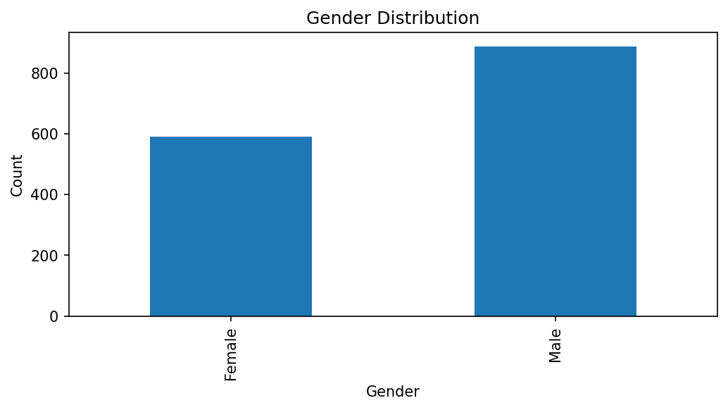
Figure 2 – Age Histogram
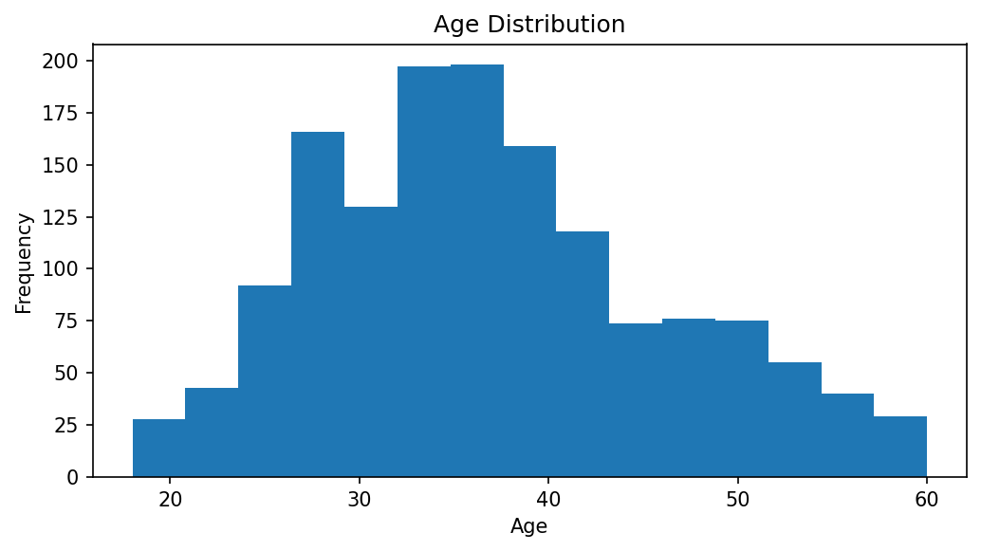
Figure 3 – Age Group Distribution
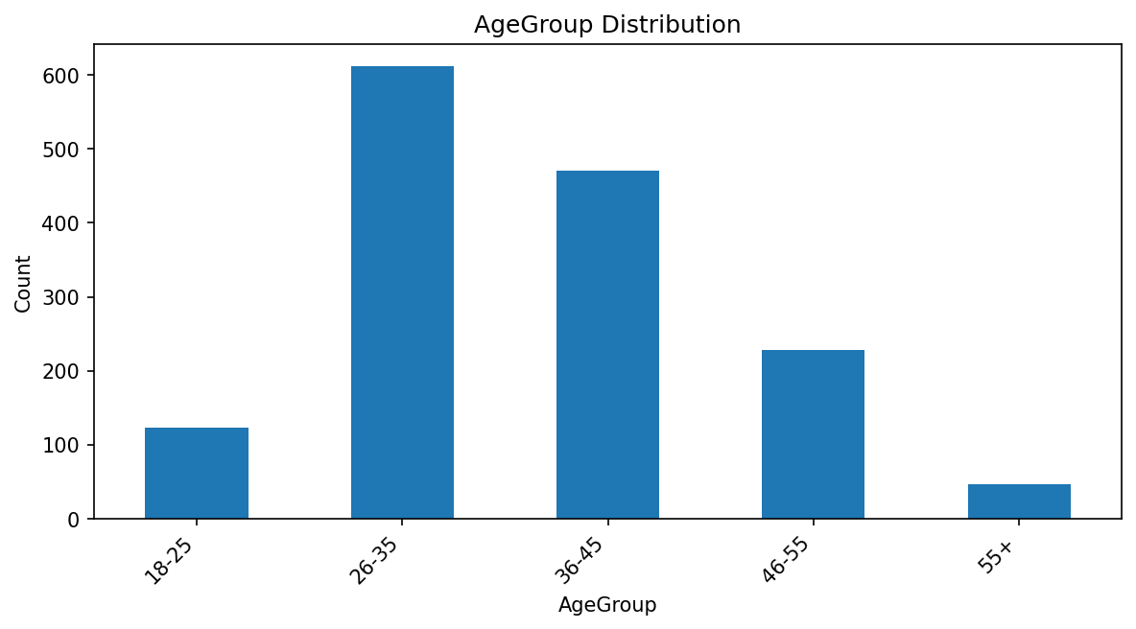
Figure 4 – Department Distribution
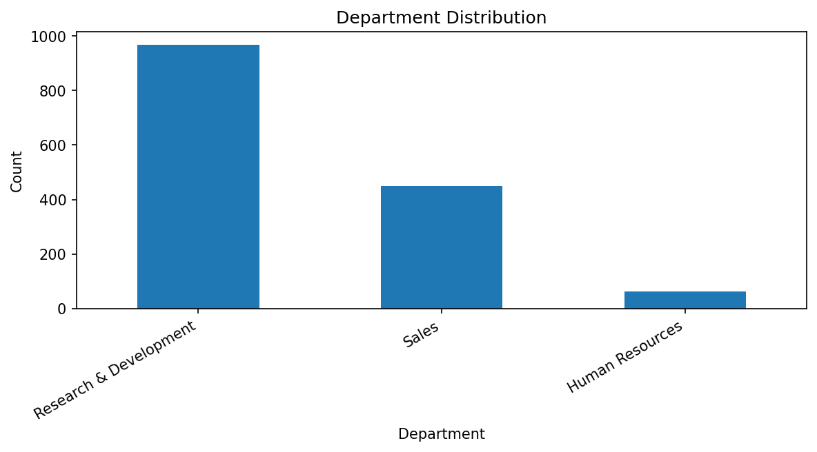
Figure 5 – Attrition Distribution
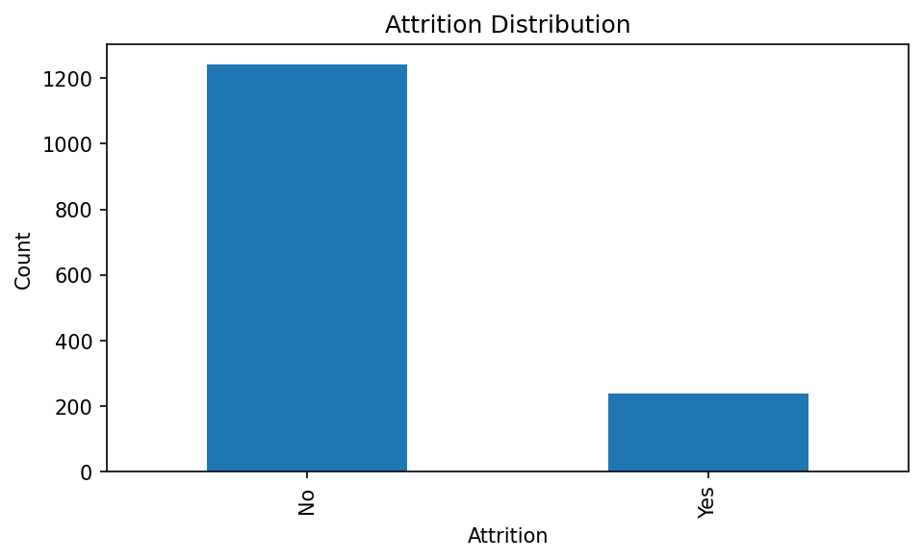
Figure 6 – Attrition Rate by Gender
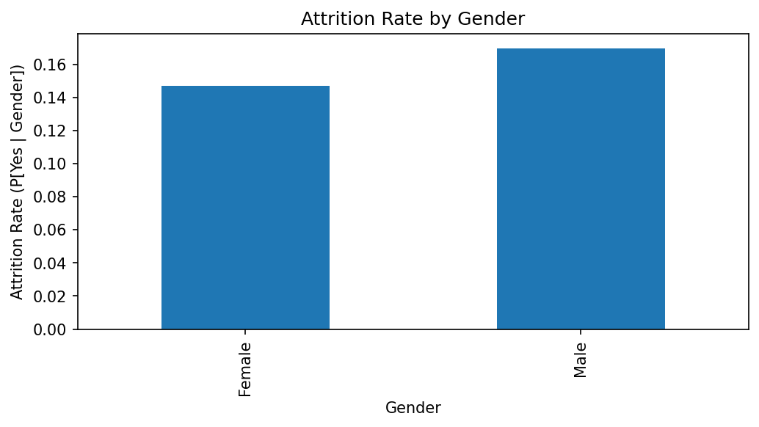
Figure 7 – Attrition Rate by Education Level
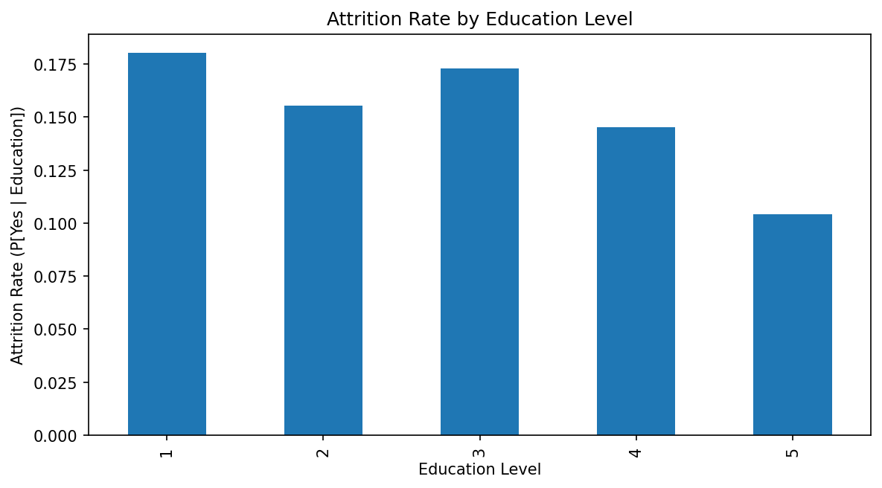
Figure 8 – Attrition Rate by Age Group
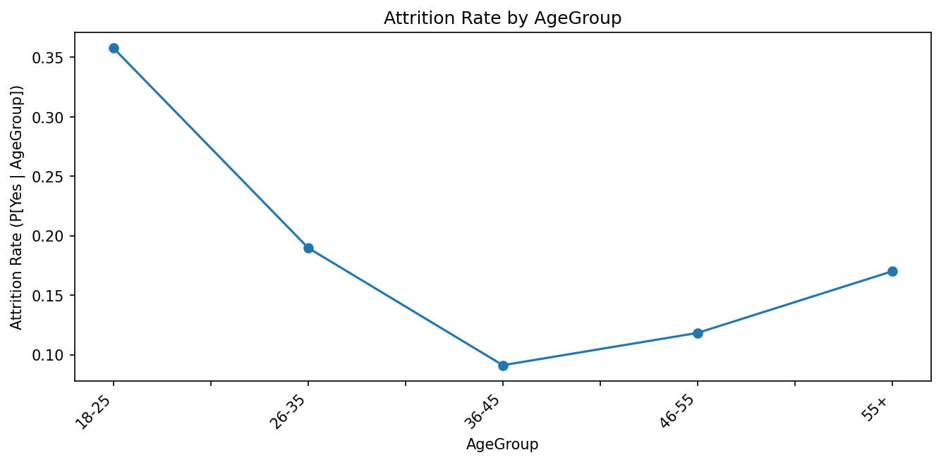
Figure 9 – Attrition Rate by Overtime Status
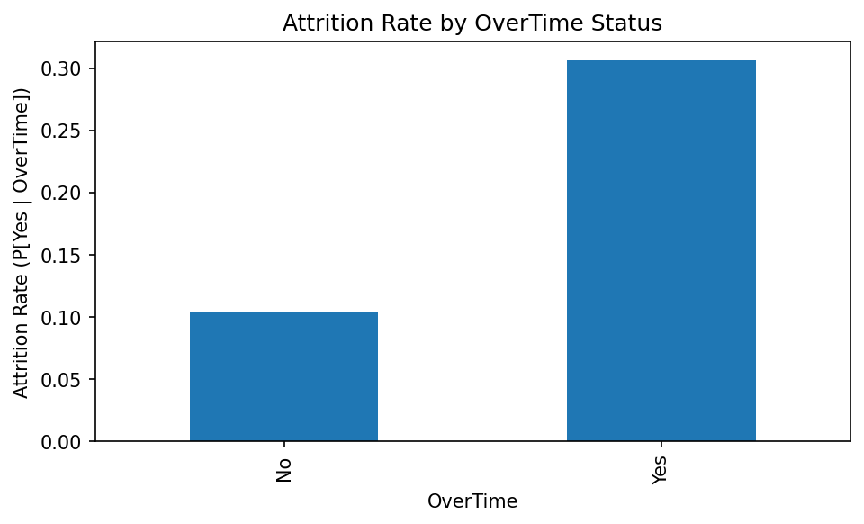

Figure 11 – Monthly Income by Gender
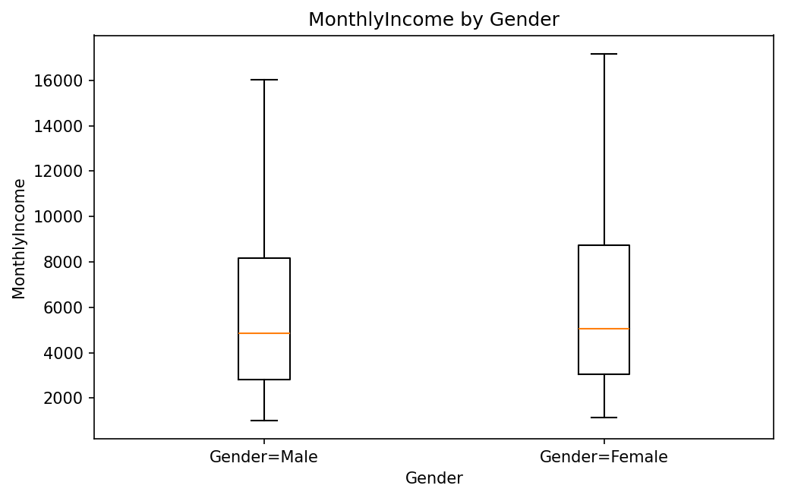
Figure 12 – Monthly Income by Gender within Job Level
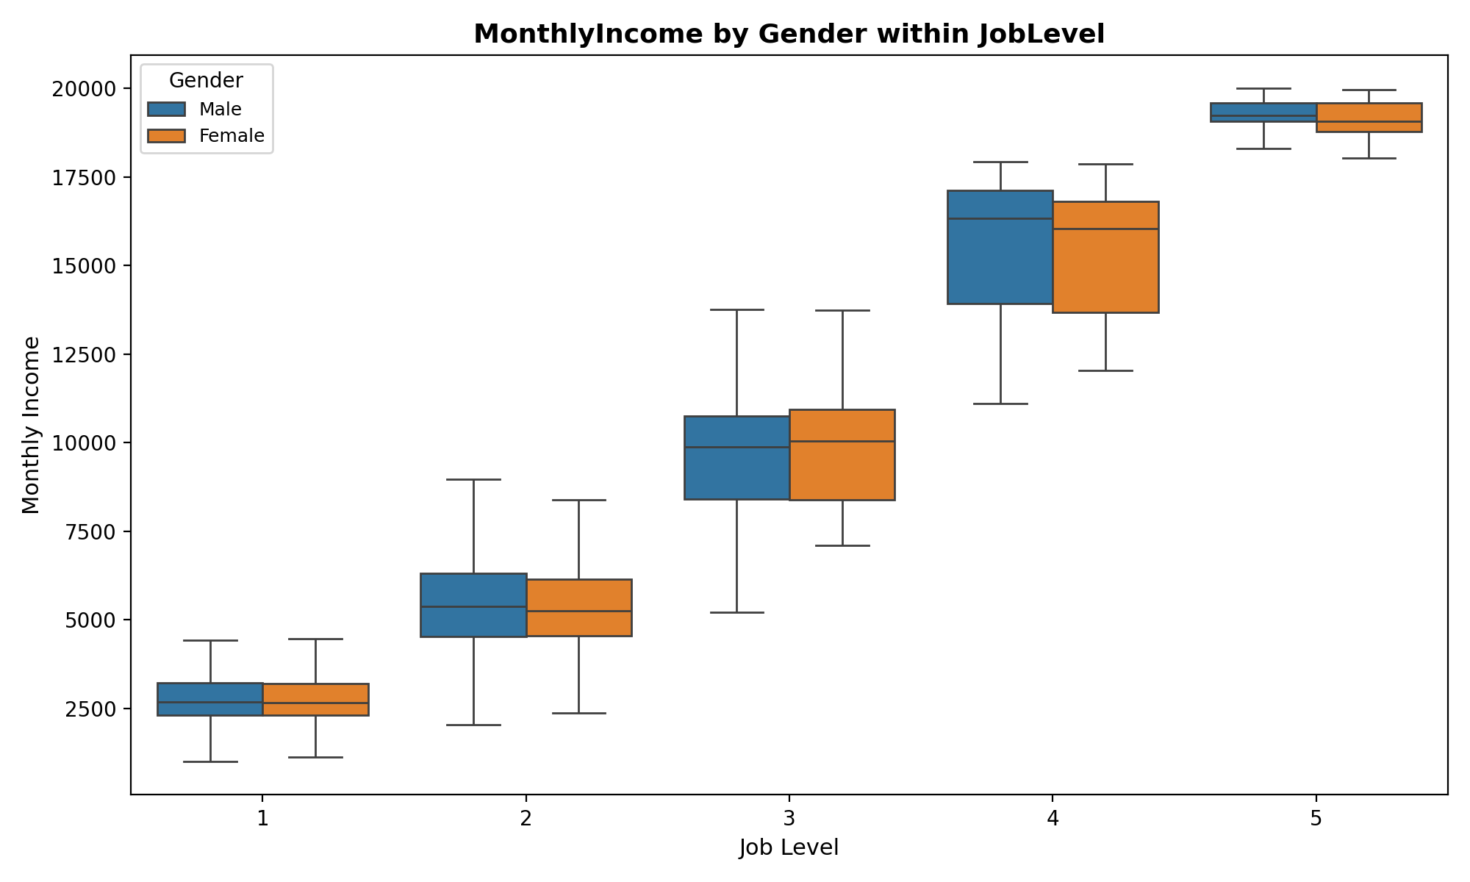
Figure 13 – Correlation Heatmap of Numeric Features
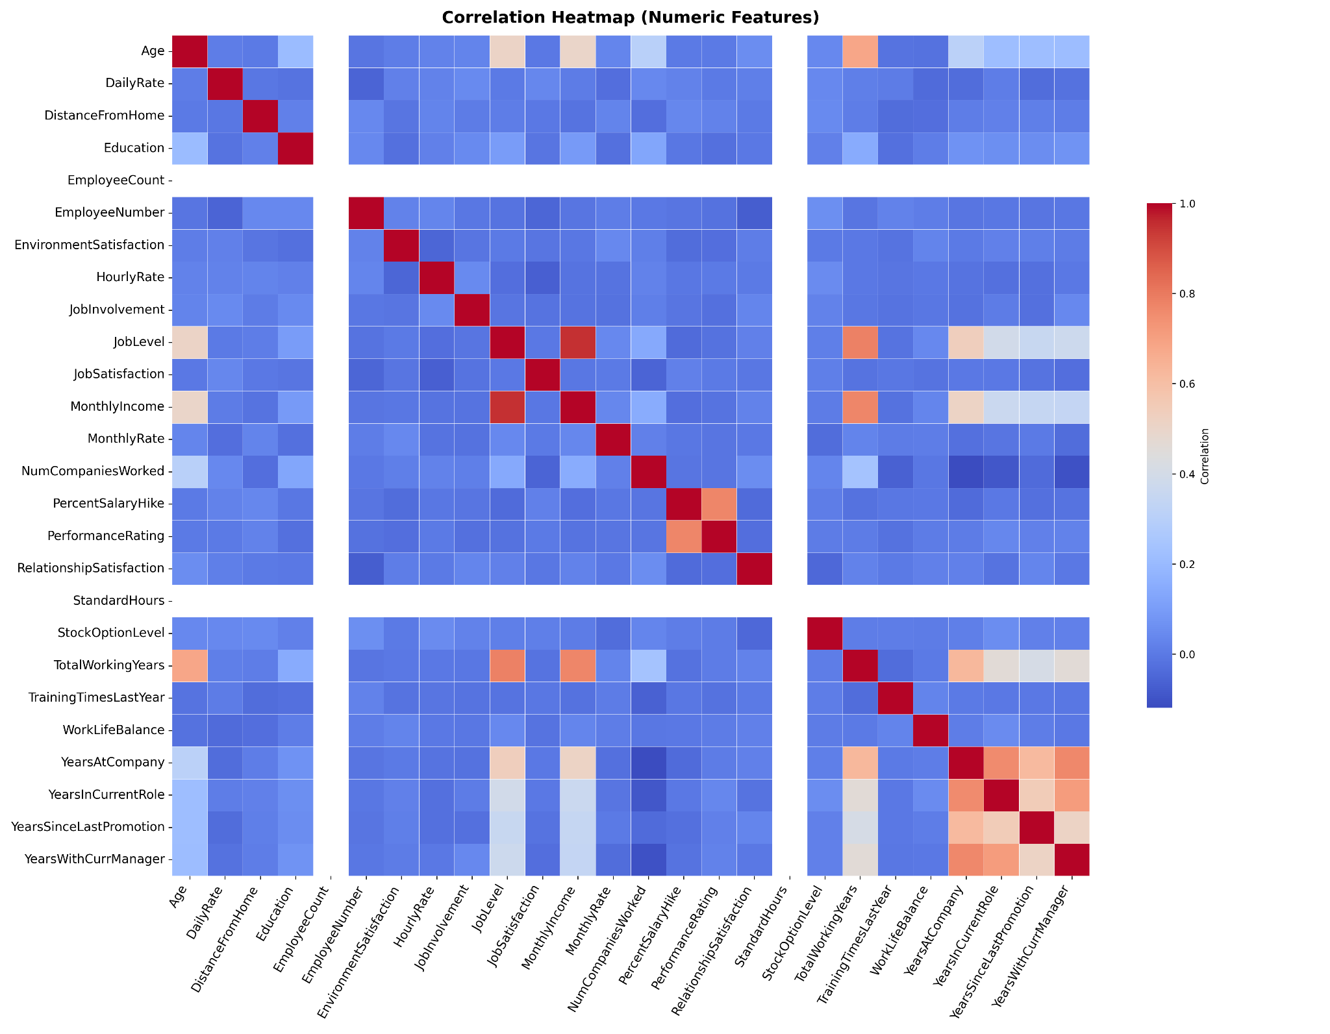

References
[1] A. Fabris et al., “Fairness and bias in algorithmic hiring: A multidisciplinary survey,” ACM Transactions on Intelligent Systems and Technology, vol. 16, no. 1, pp. 1–54, Jan. 2025, doi: 10.1145/3696457.
[2] J. Stypinska, “AI ageism: A critical roadmap for studying age discrimination and exclusion in digitalized societies,” Frontiers in Artificial Intelligence, vol. 5, Sep. 2022, pmcid: PMC9527733.
[3] K. Majrashi, “Employees’ perceptions of the fairness of AI-based performance prediction features,” Cogent Social Sciences, vol. 11, no. 1, Jan. 2025, doi: 10.1080/23311975.2025.2456111.
[4] S. Pal, B. Anand, L. N. Vempaty, and G. R. Reddy, “The ethics of AI and ML: Balancing innovation and responsibility in business applications,” European Economics Letters, vol. 13, no. 5, pp. 1169–1178, Oct. 2023, doi: 10.52783/eel.v13i5.888.
[5] Xokent. (2023). HR Analytics Dataset – Employee Attrition and Performance Analysis [Data set]. Kaggle. https://www.kaggle.com/code/xokent/hr-analytics-dataset-eda
[6] H. Suresh and J. Guttag, “A Framework for Understanding Unintended Consequences of Machine Learning,” Communications of the ACM, vol. 64, no. 11, pp. 62–71, 2021. [Online]. Available: https://dl.acm.org/doi/10.1145/3442188
[7] M. Mitchell et al., “Model Cards for Model Reporting,” Proceedings of the Conference on Fairness, Accountability, and Transparency (FAT*), pp. 220–229, 2019. [Online]. Available: https://dl.acm.org/doi/10.1145/3287560.3287596
[8] I. D. Raji, A. Smart, R. Mitchell, E. Bender, M. Gebru, and J. Buolamwini, “Closing the AI Accountability Gap: Defining an End-to-End Framework for Internal Algorithmic Auditing,” Proceedings of the 2020 Conference on Fairness, Accountability, and Transparency (FAT*), pp. 33–44, 2020. [Online]. Available: https://dl.acm.org/doi/10.1145/3351095.3372873
[9] N. Mehrabi, F. Morstatter, N. Saxena, K. Lerman, and A. Galstyan, “A Survey on Bias and Fairness in Machine Learning,” ACM Computing Surveys, vol. 54, no. 6, pp. 1–35, 2021. [Online]. Available: https://dl.acm.org/doi/10.1145/3457607

